**OCTOBER II EXAM PERIOD 2022**

**OCTOBER 10 (Monday), 8:30, Inst of Microbiol, Seminar Hall, 1st floor**

* 100 questions (min 51 correct answers to pass exam); duration of exam 120 min
* Exam results – Tuesday, October 11, 10:00
* Exam results will be signed in indexes on Tuesday, October 11, 10:00-11:00,

Lab of Parasitol-Mycol (A Džamić)

* Stamp on mark in index – main building of the Inst of Microbiol (Dr Subotića 1),

ground floor, Mrs Slavica Marjanović

* If you choose wrong answer, you can mark another one but put your signature/initials beside correct answer; corrected answer without initials will not be accepted!; you can correct a maximum of 7 questions: 3-bacteriology, 2-parasitology-mycology & 2-virology
* Bringing indexes & fully completed white application form to the exam is compulsory !
* Wearing of mask is mandatory !
* Arrive on time on exam (the door should be locked 5 min after 8:30)

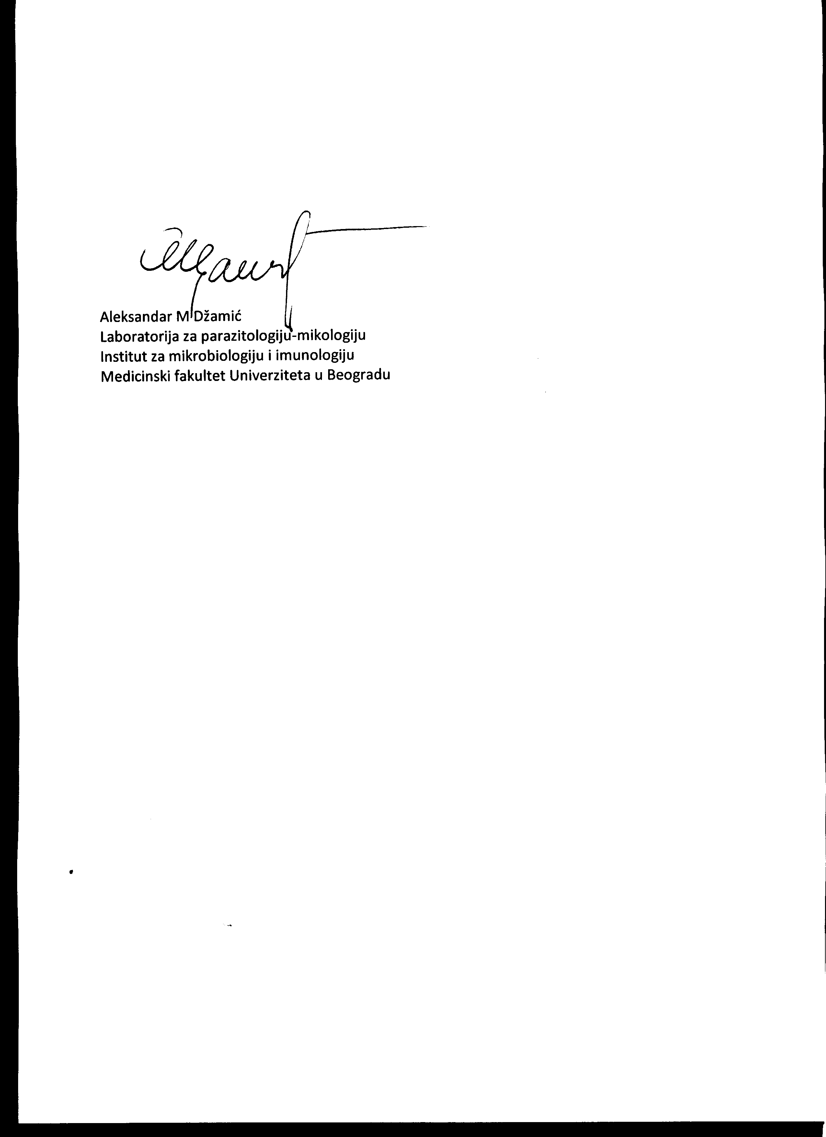

Prof AM Džamić October 6, 2022, Belgrade